AI-Enabled Student Admission System

INTRODUCTION
  - Project Overview
The AI-Enabled Student Admissions & Support Management System is a centralized Salesforce application designed to streamline and enhance student admissions using AI-driven intelligence and automation.
The system enables:
- AI-based student application prioritization
- Intelligent admission and discount recommendations
- Risk identification for enrollments
- Real-time alerts for high-priority applications
- Centralized visibility into admission performance

  - Purpose
The primary purpose of the AI Enabled Student Admission System is to digitize and automate the student admission process by providing a unified Salesforce-based platform that minimizes manual intervention and enhances operational efficiency.
The project aims to:
- Centralize student and course information in a single CRM platform.
- Streamline the admission workflow from application submission to final enrollment.
- Automate repetitive administrative tasks through Salesforce Flow.
- Implement secure access using Salesforce security features.
- Provide real-time insights through reports and dashboards.
- Utilize Agentforce AI to assist counselors, administrators, and support staff with intelligent recommendations and automated responses.
- Improve communication between students and institutional staff.
- Enable faster decision-making with AI-powered assistance.
The solution demonstrates how Salesforce CRM can be applied to solve real-world educational management challenges using declarative tools without requiring custom Apex development.

IDEATION PHASE
  - Problem Statement
Many educational institutions continue to manage student admissions using spreadsheets, emails, paper forms, or multiple disconnected software applications. These traditional methods introduce several operational challenges that reduce efficiency and increase administrative workload.
These issues result in slower admission processing, reduced productivity, and poor user experience.
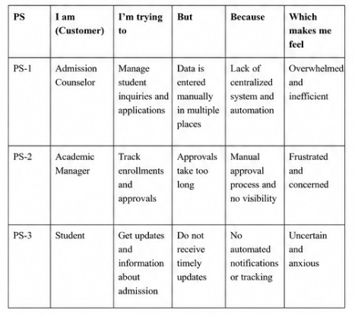
  - Empathy Map Canvas
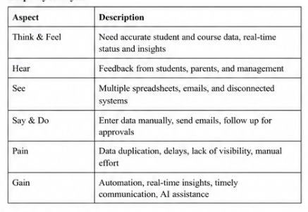
  - Brainstorming
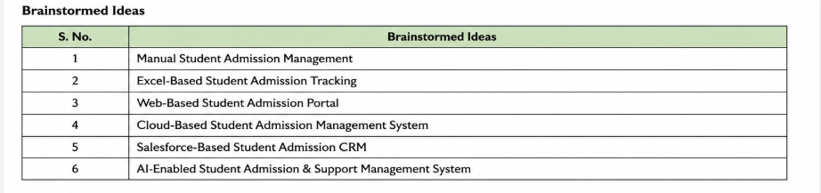
  - Idea Selection
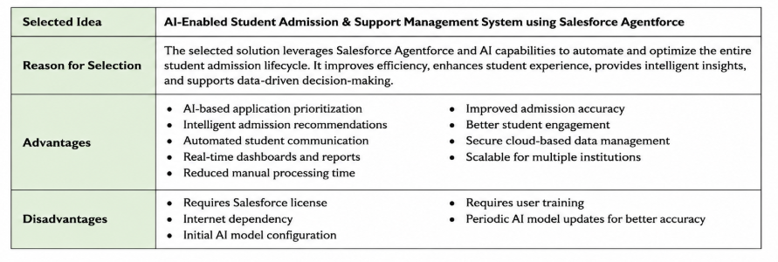

REQUIREMENT ANALYSIS
  - Customer Journey map
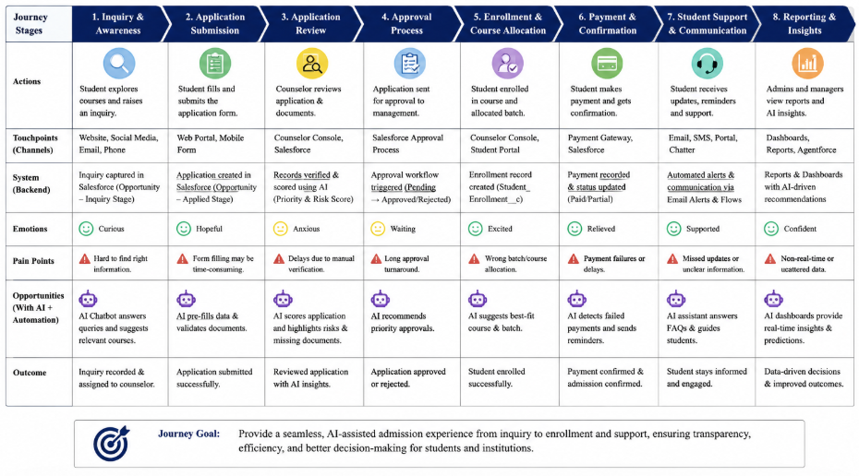

  - Solution Requirements
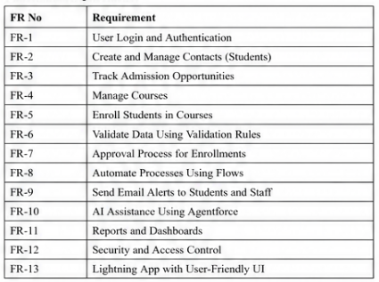
  - Data Flow Diagram
The Data Flow Diagram illustrates how student admission information flows through the Salesforce-based system. Students submit applications, which are stored in Salesforce objects. Agentforce AI analyzes each application and generates priority scores, risk assessments, and admission recommendations.
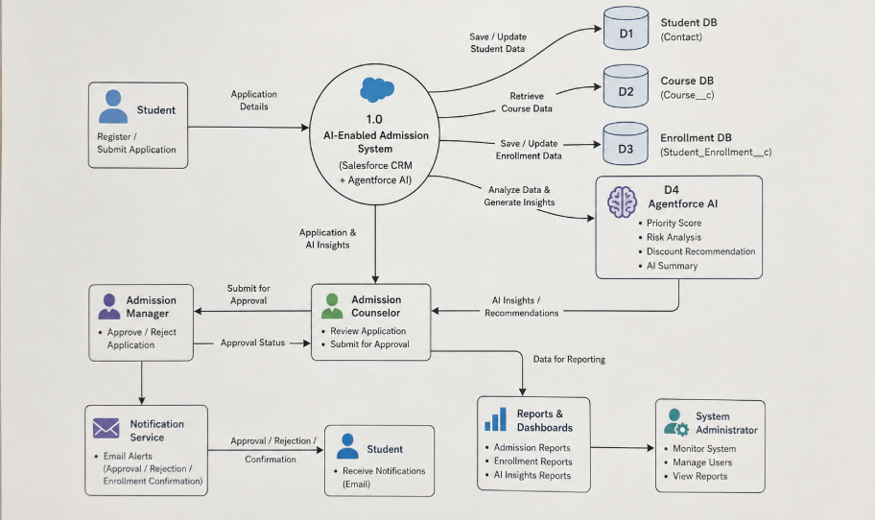
3.4 Technology Stack
The AI-Enabled Student Admission & Support Management System is developed using Salesforce's low-code platform and AI capabilities. Salesforce Lightning Experience provides the user interface, while Flow Builder automates admission workflows. Agentforce delivers AI-powered recommendations and insights for admission counselors. Data Import Wizard and Data Loader are used for migration, while Reports and Dashboards provide analytics. Validation Rules, Approval Processes, and Salesforce Security ensure accurate and secure data management.
A technology stack pyramid or layered diagram:
Users
│
Lightning Experience
│
Salesforce CRM Platform
│
Flow Builder | Agentforce AI
Approval Process | Validation Rules
│
Data Loader | Data Import Wizard
│
Reports & Dashboards

PROJECT DESIGN
  - Problem Solution Fit
Traditional admission systems rely on manual processes, spreadsheets, and disconnected tools, leading to duplicate records, delayed approvals, and poor visibility. The proposed Salesforce solution addresses these issues by centralizing student information, automating admission workflows, and providing AI-powered recommendations for faster and more accurate decision-making.
  - Proposed Solution
The proposed solution is a Salesforce-based application that manages students, courses, and enrollments using standard and custom objects. Agentforce analyzes admission data to prioritize applications, identify risks, and recommend actions. Automated approval workflows, email notifications, reports, and dashboards help counselors and administrators manage admissions efficiently.
  - Solution Architecture
The system architecture consists of users interacting with Salesforce Lightning Experience. Student data is stored in Salesforce objects, business logic is executed using Flow Builder and Approval Processes, Agentforce generates AI recommendations, and Reports & Dashboards provide analytical insights. Email Alerts notify users of important admission events.

PROJECT PLANNING & SCHEDULING
  - Project Planning
The project plan defines the milestones required for successful implementation. Activities include requirement gathering, object creation, automation, Agentforce configuration, testing, deployment, and documentation. Proper planning ensured timely completion and reduced implementation risks.
  - Requirement Analysis and Planning Phase
  - Salesforce Development – Backend & Configuration
  - UI/UX Development & Customization
  - Data Migration, Testing & Security
  - Deployment, Documentation & Maintenance

FUNCTIONAL AND PERFORMANCE TESTING
  - Performance Testing
Testing ensured reliable functioning of the AI-assisted student admission lifecycle, from application creation to enrollment approval and AI-driven prioritization.

Testing Types Conducted:
- Unit Testing
- Verified Apex logic (if applicable) for:
  - AI priority score calculation
  - Risk analysis logic
  - Approval status updates
- Ensured compliance with Salesforce governor limits
- Achieved required test coverage for all Apex components
- Integration Testing
- Verified relationships between:
  - Student and Student Enrollment
  - Course and Student Enrollment
- Tested interaction between:
  - Record-Triggered Flows
  - Approval Processes
  - Email Alerts
  - Agentforce prompt actions
- Validated seamless handoff between:
  - Backend automation
  - UI components
  - AI recommendations
- User Acceptance Testing (UAT)
- Conducted with sample users:
  - Admission Counselor
  - Admission Manager
  - System Administrator
UAT Scenarios:
- Creating and updating student records
- Creating student enrollments
- Automatic AI priority identification
- Submitting high-discount enrollments for approval
- Reviewing AI-generated summaries and risk insights
- Approving or rejecting enrollments
- Receiving email alerts and notifications
Outcome:
- User feedback collected and implemented
- Improved clarity of AI priority indicators
- Optimized page layouts for admission workflows
- Confirmed smooth operation across desktop and mobile devices

RESULTS
  - Output Screenshots
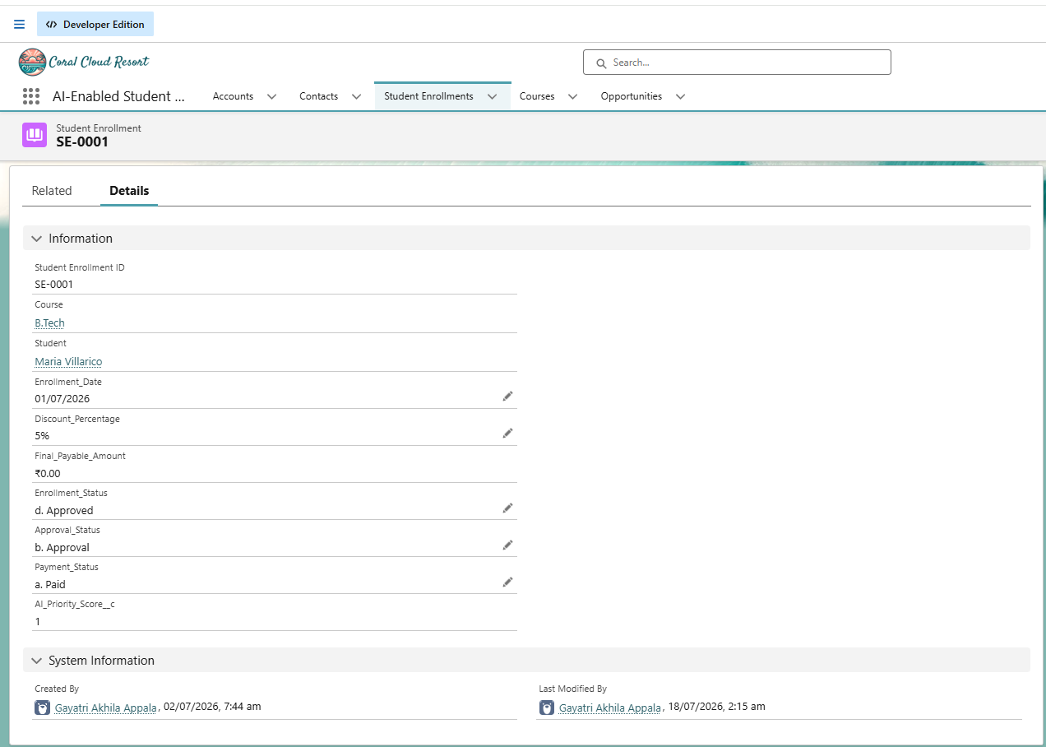
APP LAUNCHER:
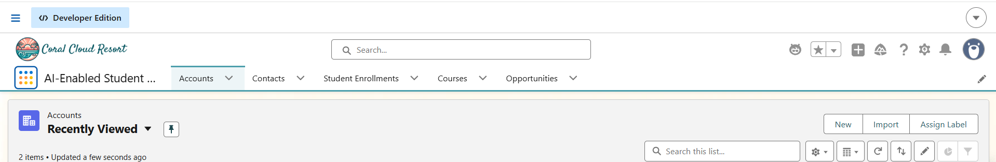
SAMPLE OUTPUT:
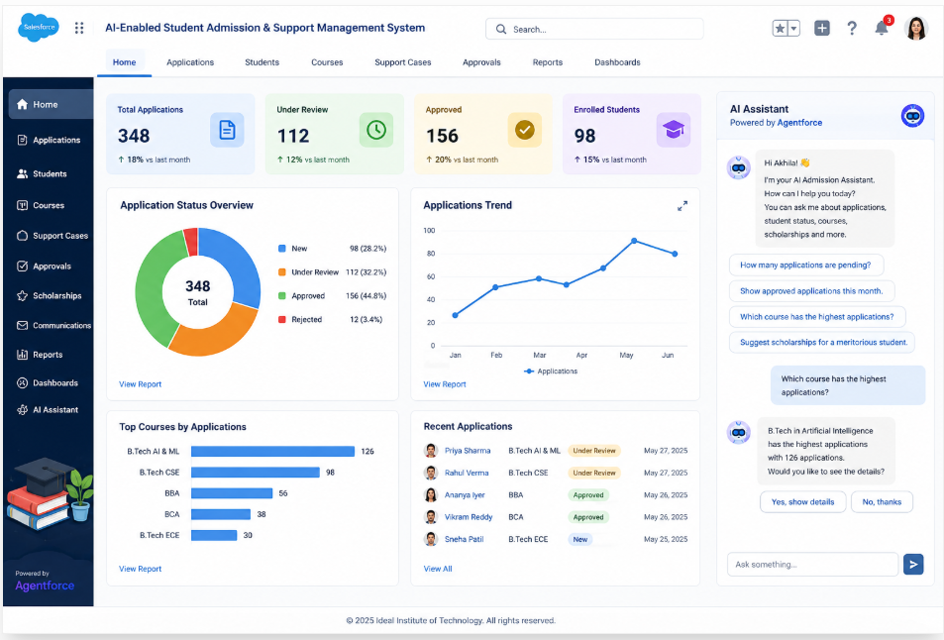
- ADVANTAGES & DISADVANTAGES
ADVANTAGES:
- Centralized management of student, course, and enrollment data.
- AI-powered recommendations for faster admission decisions.
- Automated workflows reduce manual effort and approval time.
- Secure role-based access protects sensitive information.
- Real-time reports and dashboards improve decision-making.
- Scalable and easy to maintain using Salesforce's low-code platform.
DISADVANTAGES:
- Requires Salesforce licenses and cloud infrastructure.
- Users need training to effectively use Salesforce and Agentforce.
- Performance depends on internet connectivity.
- AI recommendations rely on accurate and complete data.
- Advanced customizations may require Apex development.
- CONCLUSION
The AI-Enabled Student Admission & Support Management System successfully demonstrates how Salesforce CRM and Agentforce AI can be utilized to modernize and automate the student admission process. The application provides a centralized platform for managing student information, course details, enrollments, approvals, and communication while reducing manual effort through intelligent automation.
By implementing custom objects, validation rules, approval processes, email automation, Lightning components, Dynamic Forms, and Salesforce Flows, the system streamlines admission workflows and ensures data accuracy. The integration of Agentforce AI enhances decision-making by providing intelligent recommendations, risk analysis, and application prioritization, enabling admission teams to process applications more efficiently.
The project also emphasizes security through role-based access control, profiles, and sharing rules, ensuring that sensitive student information is protected. Comprehensive testing and deployment practices ensure that the application is reliable, scalable, and ready for real-world implementation.
- FUTURE SCOPE
- Develop a student self-service web/mobile portal.
- Integrate AI chatbot for 24/7 admission support.
- Add online fee payment and document OCR verification.
- Implement predictive analytics for admission trends.
- Integrate with Learning Management Systems (LMS) and WhatsApp/email notifications.
- APPENDIX

GitHub Link: https://github.com/gayatriakhila/AI-Enabled-Student-Admission-System

Project Demo Link: https://drive.google.com/file/d/1xa70_b0EjwGppXdk6bFOh6YbHZN9lAZ2/view?usp=sharing

